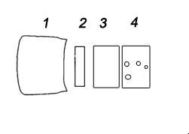

LensCoat® Canon 70-300 f/4.5-5.6 IS INSTRUCTIONS

Piece 1- Lens Hood Cover
Remove the lens hood cover from the lens. Carefully slide and stretch the lens cover into place.

Piece 2
With the lens hood removed, stretch and slide piece 2 down from the glass to just above the focus ring.

Piece 3
Slide piece 3 over the lens and position on the zoom ring.

Piece 4
Slide on piece 4 by lining up the 1/8 hole to the lens mount mark (red dot) on the lens and the holes for the AF and IS controls, being careful not to pull/stretch the holes too much to prevent tears.

LensCoat.com®
80 Throckmorton Street
Freehold, NJ 07728

